Appendix

1. Periodic Progress Report (PPR)
2. Business Model Canvas (BMC)

Image:

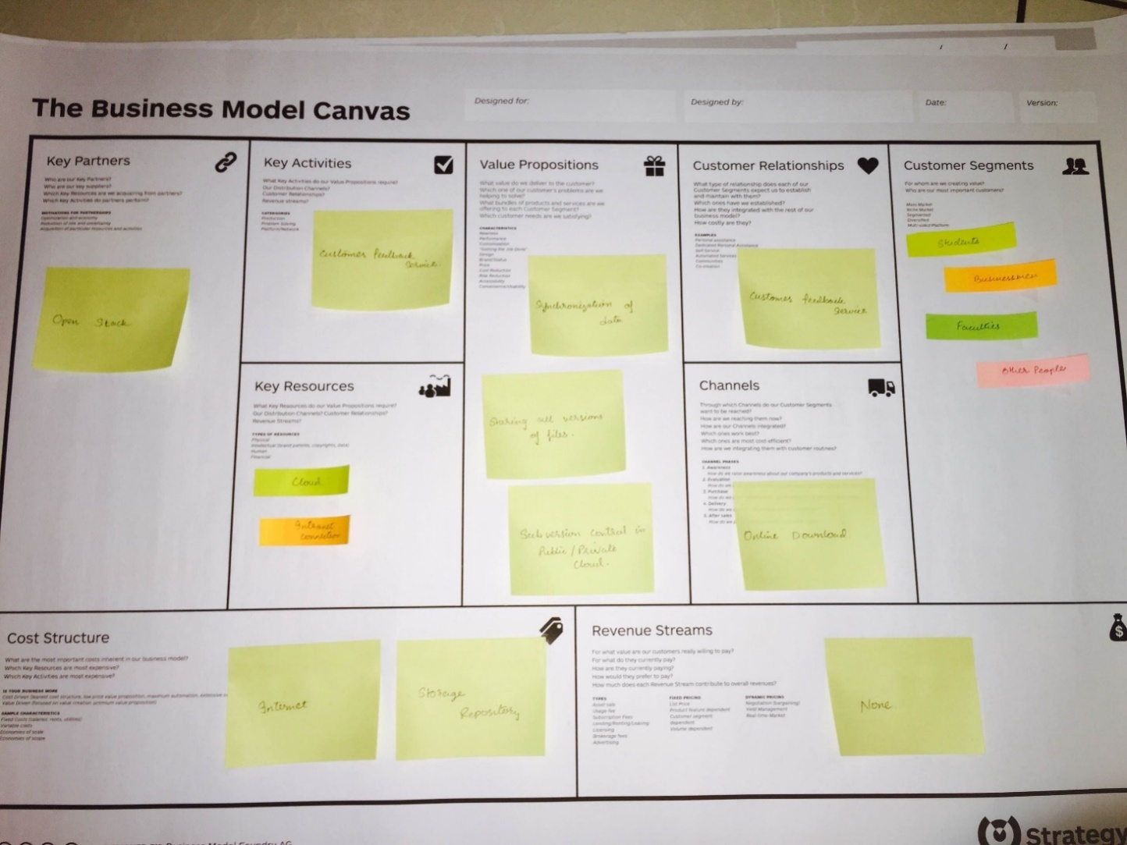

**Report:**

Key Partners-

* This project is developed by Dhruv Patel, Neel Patel, Dip Dhanesha.

Key Activities-

* Speaking about revenue streams, the application has no revenue system.
* The customers are related by customer feedback system of the software which allows the customers to give their valuable feedback.
* The Software will be distributed by websites, as a distribution channel.

Value Propositions-

* Free of cost.
* Providing private cloud for subversion control through intranet.
* Subversion control in public cloud using internet and private cloud using intranet connections.

Customer Relationships-

* Software contains a customer feedback service, so that the customers can give their valuable feedback and suggestions regarding the application.

Channels-

* The main channel for distributing the software is Official Website.

Customer Segments-

* Businessman- This Software helps businessmen by keep their records up- to-date in day to day business life. in a business system all the records and data are updated frequently, so if any corruption occurs all versions of files can be available through sub versioning system.
* Students- this helps student to divide their load of work by installing this system and parallel working on the same project or solving the same problem at a time.
* Employers- The employers of a company can parallel work on the same file and update the file according to their wish. All the versions of file will be stored in the system with same name but different versions so that user can access the file at any instance.
* Faculties- This software can also be useful for faculties in the school and colleges. In a campus of university the systems are inter connected through LAN connection, so by using subversion system the faculties can access or work on the same file and store different versions with same name for further use.
* General people- This Software can be useful to any group of people working together on a particular file or project to divide the load of work.

Key Resources-

* The main key resources needed here is internet, cloud storage for master repository, OpenStack, intranet connection.

Cost Structure-

* The only cost affected in the application is-
* Internet- for Syncing files in public cloud.
* Cloud Storage- Enough storage space for syncing all versions of files and storing them with respect to time instance.

Revenue Streams-

* As this Software can be used by anyone, revenue streams are not yet decided.

1. Patent Drafting Exercise (PDE)